**POPULATION IN AFRICA**

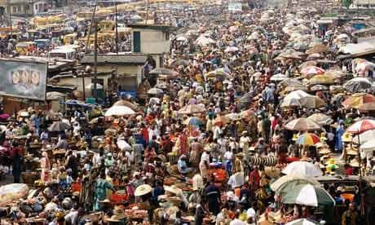

**Activity; understanding the concepts related to population.**

Task

**In groups, carry out a text book research and find out the meaning of the following concepts**

**Population**

**Population growth rate**

**Population distribution**

**Population density**

**Birth rate**

**Death rate**

**Fertility rate**

**Migration**

**Emigration**

**immigration**

**Student’s responses**

**Population** is the number of people living in a given area in a given period of time.

**Population growth rate** is the rate at which the population size of a country or an area is increasing over time

**Population distribution** refers to how people are spread across a given area,region or country.

**Population density** refers to the total number of people per square kilometer. $population density=\frac{total population}{total land area}$ = x people per ${km}^{2}$

**Birth rate** is the number of children born alive per 1000 people of the country’s population.

**Death rate** is the number of deaths per 1000 people of the country’s population.

**Fertility rate** is the average number of children born by each female in the child bearing age bracket.

**Migration** refers to the movement of people from one place to another.

**Emigration** is the act of leaving one’s own country to settle permanently in another.

**Immigration** is the coming to live permanently in a foreign country.

**ACTIVITY; exploring the concept of population distribution in Africa**

**Background**

In Africa the densely populated areas include: the Nile valley, Nile delta, Niger delta, Maghreb of North West Africa, Johannesburg industrial areas of south Africa, West African coastal region etc

The moderately populated regions are:

* Ethiopian highlands
* Margins of the densely populated areas

The sparsely populated areas include:

* Sahara desert areas
* Namib and Kalahari Desert areas
* Hot-wet forests such as the Congo basin areas

Task

Individually, using an atlas, draw a sketch map of Africa showing population distribution.

**Response**

**A sketch map of Africa showing population distribution**

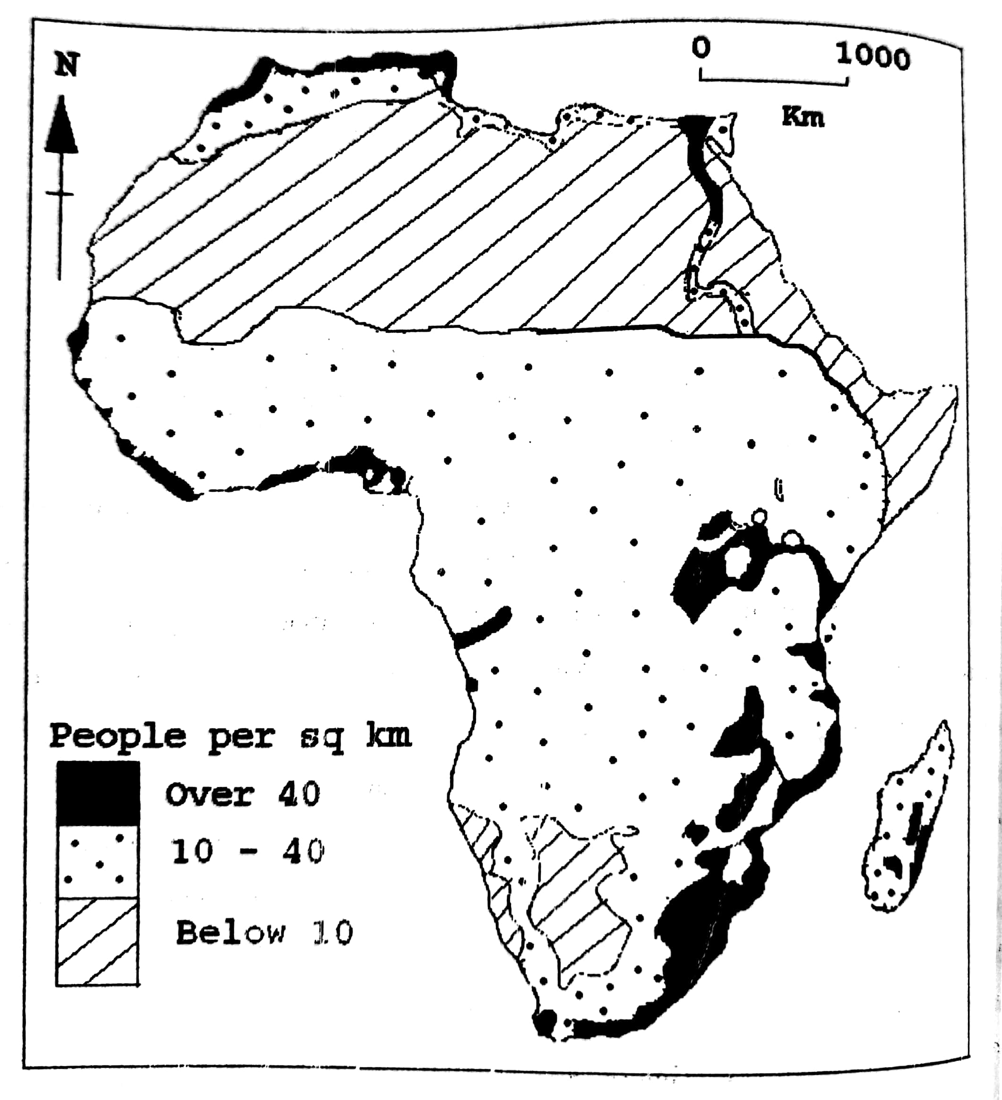

**ACTIVITY; Understanding factors influencing population distribution in Africa.**

**Task**

**In groups, carry out an internet search or text book research and find out the factors influencing population distribution in Africa.**

**Student’s responses**

**Physical factors**

1. Climate

* Areas which receive heavy and reliable rainfall favor arable farming/ crop growing hence attracting dense population settlement such as south east Nigeria.
* Areas which receive low and unreliable rainfall discourage arable farming leading to sparse population such as Kalahari Desert areas.

1. Soils

* Areas with deep / well drained fertile soils promote crop growing hence attracting dense population such as the fertile alluvial soils South West and South East Nigeria
* Areas with thin /infertile soils limit crop growing hence leading to low population density such as the Sahel region.

1. Altitude

* Areas of low altitude have warm conditions which attract dense settlement such as the coastal regions.
* Areas of high altitude have cool temperatures which attract low population settlement.

1. Relief

* Areas with rugged relief/ mountainous landscape are inaccessible/ limit construction and mechanization leading to low population settlement.
* Areas of fairly/ relatively flat relief/ gentle slopes encourage construction and mechanization hence leading to dense settlement.

1. Vegetation

* Areas with thick vegetation cover hinder transport routes/ are not easy to clear, and thus have low population settlement such as the Congo basin with tropical rain forests.
* Areas of savanna grasslands are easy to clear for various activities such as farming and thus have dense settlement.

1. Biotic factors

* Areas infested with diseases causing vectors such as tsetse flies and mosquitoes etc scare away people leading to sparse population settlement such as the areas occupied by the Fulani in Nigeria.
* Areas free from disease causing vectors attract more people to settle and carry out various activities leading to dense settlement.

1. Drainage

* Water logged areas/ Poorly drained areas/ areas with periodic flooding have low or moderate population density due to problems in cultivation and construction.
* Well-drained areas encourage construction and growing of various crops leading to dense population.

**Human factors**

1. Economic activities such as industry

* Areas with more economic activities such as mining, industry provide more job/employment opportunities and hence attract dense settlement.
* Areas with limited economic activities such as mining and industry have less chances of employment, hence have low population density.

1. Transport and communication routes

* Areas with developed transport system/ along main roads and coastal areas are easily accessible/ promote economic activities, hence attracting dense settlement.
* Areas which are remote / far from main roads are less accessible / limit economic activities leading to sparse population settlement.

1. Duration of settlement/ ancient political kingdoms

* Areas of ancient kingdoms / with long history of settlement with strong kingdoms attract more opportunities up to today such as trade, jobs; and thus, dense settlement.
* Areas of relatively recent settlement/ which had weak kingdoms have fewer opportunities for development leading to sparse population settlement.

1. Government policy

* Government policy of forest conservation (such as national parks, forest reserves) discourages settlement in such areas leading to sparse population.
* Government policy of resettlement schemes, infrastructural development attract settlement leading to moderate to dense settlement.

1. Political climate/situation

* Areas which are politically stable encourage productive activities such as trade, farming leading to dense settlement.
* Areas which are insecure/ unstable discourage productive activities like trade leading to sparse settlement.

**ACTIVITY: calculating population density.**

Total population

Population density=

Total land area

|  |  |  |
| --- | --- | --- |
| **country** | **Population(millions)** | **Area(sq km)** |
| **Rwanda** | **13000000** | **26338** |
| **Burkina Faso** | **20900000** | **274122** |
| **Lesotho** | **2100000** | **30355** |
| **Egypt** | **100800000** | **1002000** |
| **Democratic. Rep. of Congo** | **89600000** | **2344885** |

**Task**

**You are provided with a formula and the table above, use them in your group to;**

1. Calculate population density for the countries shown
2. Draw a simple bar graph to represent your results in 1 above
3. What do the results tell you about the population density of the countries shown?
4. Share your work with the rest of the class

**Activity; understanding the General causes of high population density**

**Task**

**In pairs carryout text book research and find out the general causes of high population density. Share your work with another pair for comparison and make additions were necessary.**

**Learners’ findings**

1. Heavy and reliable rainfall encourages crop farming / arable farming hence attracting dense population.
2. Presence of deep and well-drained soils / fertile alluvial soils which promote crop growing such as rice and maize growing leading to dense settlement.
3. Low altitude leading to warm conditions which attract dense settlement.
4. Relatively flat/ gently sloping landscape which encourages mechanization / construction leading to dense population.
5. Presence of abundant mineral resources which offer more chances of jobs and thus dense population.
6. Presence of many economic activities such as developed industry and trade which offer more jobs leading to dense population settlement.
7. Efficient / developed transport by road and railway which increase accessibility/ promote various activities leading to dense settlement.
8. Long duration of settlement in some regions with strong ancient kingdoms such as Yoruba land in Nigeria.
9. Favorable government policy of building industries, power stations and other infrastructure in some areas attracts dense population there.
10. Political stability which favors various economic activities such as trade leading to dense population.

**Activity: discussing the advantages and disadvantages of high population density.**

**Task**

**In your group, carryout a discussion about the advantages and disadvantages of high population density. Present your outcomes to the rest of the class.**

**Outcomes of group discussions are as follows;**

**Advantages of high population density**

1. A large population size widens the market /demand for goods and services, and this in turn promotes investment/ production.
2. promotes the production process/ investment. (Labour also becomes cheap for investors).
3. Increases pressure on government to undertake development programs such as providing social and economic infrastructure like roads, schools, and hospitals to cater for the increasing population.
4. Promotes hard work, innovation and invention among the population. Many people work harder in order to survive in the competitive environment such as through agricultural modernization-intensive farming methods, hence high production.
5. Encourages exploitation of idle resources such as minerals, water resources, in order to sustain the increasing population, hence reducing resource wastage.
6. Reduces the social overhead costs per person in the country. It becomes more economically cheaper to provide social services since they are utilized by many people.
7. Increases the tax potential due to many people and activities to tax; thus, increasing government revenue for social services like providing health and education services.
8. Encourages urbanization / development of towns as population increases. Population concentrates in some areas/ towns, leading to the setting up and expansion of facilities like transport networks, medical facilities, banking facilities etc.

**Disadvantages/problems of high population density**

1. It increases the dependence burden, because many unproductive people/ children depend on the small productive population. There is high expenditure on education, food, housing, medical care, clothing and hence reduced savings and investment.
2. Strains the government budget / leads to increase in government expenditure on social services such as education, medical care, and this results into dependence on external donations and loans.
3. Increases income inequality by widening the economic gap between the rich and the poor. People with resources become richer while those without become poorer. (The rich exploit the poor such as through under payment).
4. Increases the level of unemployment; because the rate at which the population increases is higher than the rate of job creation and this leads to increased poverty.
5. Results into over exploitation of natural resources like minerals, water resources, and this leads to quick exhaustion and denies the future generations a chance to use them.
6. It increases rural-urban migration since many people move to the urban areas in search for jobs and hence leading to associated problems like increased crime, social unrest.
7. Leads to excessive reliance/ dependence on foreign aid in form of food, medical services, grants, loans in order to support the rapidly growing population, and this leads to unnecessary conditions from the donor countries.
8. Leads to increase in brain drain since many qualified professionals /highly skilled workers continue leaving the country to look for better opportunities in other countries, and this reduces domestic production.
9. It increases pressure on land/ shortage of land for settlement and cultivation, and this in turn leads to land conflicts and land fragmentation.
10. Leads to reduced productivity of land due to over-use for cultivation leading to lower yields.
11. Inadequate accommodation leads to the growth of slums and associated problems like high crime rate, poor housing, poor health facilities, alcoholism, and drug abuse.

**Activity; finding out the possible solutions to the problems of high population density.**

**Task**

**In groups, use the senior 4 learners’ book, and find out the possible solutions to the problems of high population density. Write your findings in your book.**

**Learners’ findings**

1. Encourage the use of birth control practices such as family planning devices to reduce on the rate of population growth.
2. Population control policies / legislations should be undertaken to limit large families such as one child per family policy, marriage age legislation.
3. Encourage celibacy and late marriages among the people to reduce on the birth rate and population increase.
4. Development of more natural resources such as soils, power, forests to support the bigger numbers of people.
5. Encourage agricultural modernization to realize higher foods supplies /yields from the existing farmland such as through agricultural research, farm technology, swamp reclamation, desert irrigation to support the large population.
6. Encourage out-migration to relieve population pressure such as by establishing small industries in the under populated areas.
7. Discourage rural-urban migration through putting up more social services in the rural areas such as modern schools, high grade hospitals.
8. Strengthen education to change/ decampaign traditional attitudes to reduce birthrates, by delaying marriages.
9. Export the labour force such as expatriates/ skilled workers who are unemployed to other countries. However today fewer governments are prepared to accept immigrants.
10. Addressing poverty/ encourage income generating activities such as farming and trade so as to improve income and general standards of living among the people. This also involves encouraging organizations with anti-poverty programs.
11. Encourage Women empowerment programs such as enhancing their education, political and economic opportunities to reduce on birth rates.
12. Setting up resettlement schemes for the people from the densely populated areas.
13. Encourage vertical expansion of towns using storied buildings/ sky scrapers to create land for various activities.
14. Land reform policy like land consolidation to control land fragmentation.

**Activity; understanding the general causes of low population density.**

**Task**

**In pairs or groups, Carryout an internet search and find out general causes of low population density, swap your finding with other groups and make changes where necessary.**

**Learners’ responses**

1. Little and unreliable rainfall which discourages crop farming and thus leading to low population density.
2. Presence of infertile soils which discourage crop growing, hence limiting settlement such as desert sandy soils.
3. High altitude leading to cold temperatures which discourages settlement.
4. Rugged relief/ mountainous landscape/ steep slopes which limit construction/ mechanization and hence limiting settlement.
5. Presence of thick forest vegetation such as dense tropical forests of Gabon and Congo basin which hinders transport routes and contrition, hence discouraging settlement.
6. Presence of Pests/ disease causing vectors such as mosquitoes in dense forests which scare away people.
7. Low-lying areas subject to flooding/ water logged conditions / poor drainage like swampy areas which discourages farming/ threaten life and thus discourage population settlement.
8. Limited economic activities especially industry and farming, hence few job opportunities which limits settlement, hence low population density.
9. Remoteness with no developed transport routes which limits economic activities/ limits accessibility, thus causing sparse settlement.
10. Political instability which discourages construction of permanent structures/ discourages productive activities such as farming, industry.
11. Government policy of forest conservation through creating forest reserves, national parks and game reserves-hence discouraging population settlement.

**Activity: understanding the advantages and disadvantages of low population density.**

**Task**

**In groups, carry out a library research or internet search and find out the advantages and disadvantages of low population density. Share your finding with other groups**

**Learners’ responses**

1. Resources are not over exploited and this benefits the future generations.
2. There is a high potential for employment opportunities, by increasing resource utilization.
3. Reduced/ low government expenditure especially on social services due to limited number of people.
4. The standards of living are easily increased by increasing resource exploitation.
5. There are fewer social costs such as pollution due to few productive activities.
6. Political and social instabilities are minimized due to limited competition for resources.

**Disadvantages of low population density**

1. There is underutilization of resources such as mineral, forest, water due to the small population. Many resources remain idle/ wasted.
2. Results into limited market size for goods and services due to small population. This undermines agricultural and industrial development.
3. Leads to labour shortages due to the small population, hence low level of a development and industrial development.
4. It is / uneconomical / very expensive for the government to develop infrastructure and provide social services like education, medical services.
5. Results into low tax revenue and this undermines the provision of social services.
6. Encourages rural-urban migration leading to under development of rural areas. Many people leave the remote rural areas attracted to the few urban areas.
7. Leads to regional imbalance in development due to uneven population distribution. People tend to stay in the most favored areas and hence infrastructure is also concentrated in those areas.
8. Results into dependence on other countries, in terms of labour supply, market, capital, and the supply of essential goods.

**Activity; discovering the possible solutions to the problems of low population density.**

**Task**

**Carryout a textbook search or internet research and find out the solutions to the problems of low population density. Present your findings to the rest of the class.**

1. Providing incentives for large families such as free housing, free education to increase the birth rate.
2. Encourage people to settle in less populated areas such as by developing the necessary infrastructure.
3. Encourage foreign investors to finance development projects in various regions, to increase population settlement in such areas.
4. Gazette under populated areas into national parks and reserves as an alternative land use, to control resource wastage.

**CASE STUDY 1**

**Activity; understanding population distribution in Nigeria**

**Background**

Nigeria is located in West Africa and is the most populated country in Africa with about 140 million people.

The population distribution is described as below:

1. The densely populated regions include:

* Southern parts along the coast
* Delta states, Ibo land
* Urban centers and the extreme north

The highly populated towns are: Lagos, Benin, Port Harcourt, and Abuja.

1. The moderately populated regions are located in the northern part particularly around Sokoto, Kano and Katsina. Also, the margins of the densely populated regions.
2. The lowly/ sparsely populated regions include: the middle belt, desert margins of the north and the forested areas of the south.

***A sketch map showing population distribution in Nigeria***

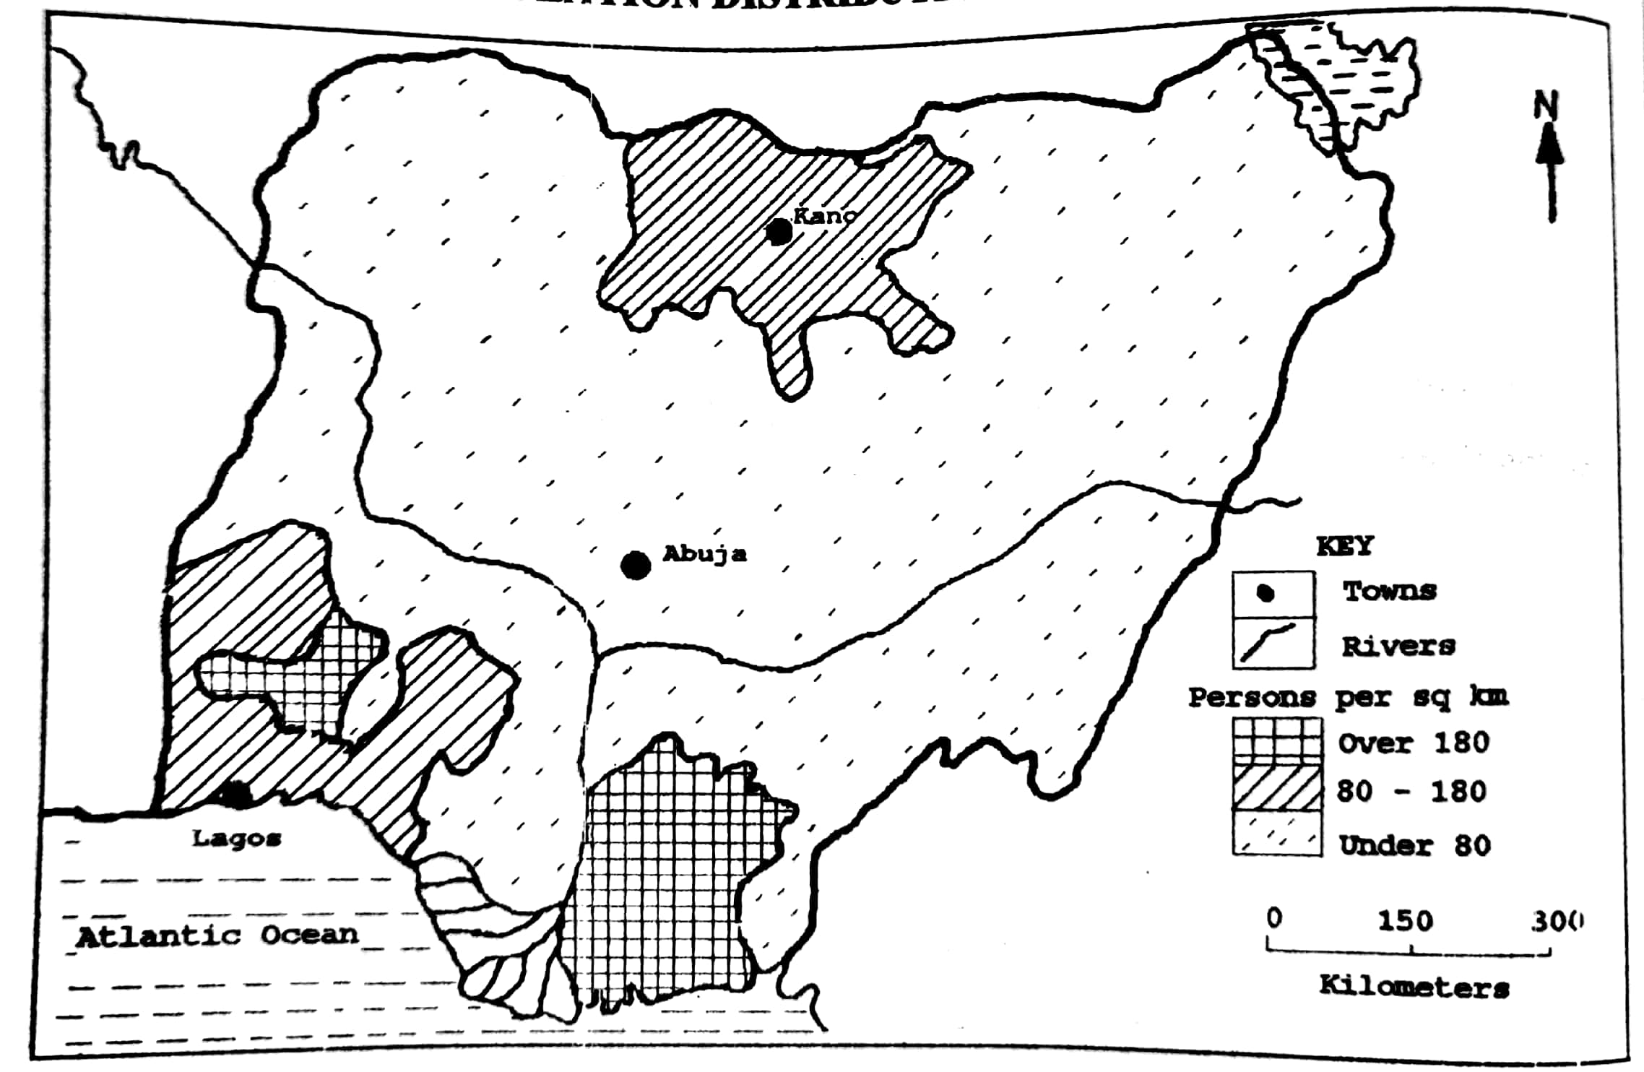

**Activity: understanding population distribution in Egypt**

**Background**

Egypt is located in North Africa. The most densely populated areas are the Nile valley and delta areas plus some of the large oases. The highly populated towns include Alexandria, Cairo, Aswan, Suez, Al Mahallah el Kubra, and Ismailiya. Throughout the rest of the country, there is a very sparse population.

***A sketch map showing population distribution in Egypt***

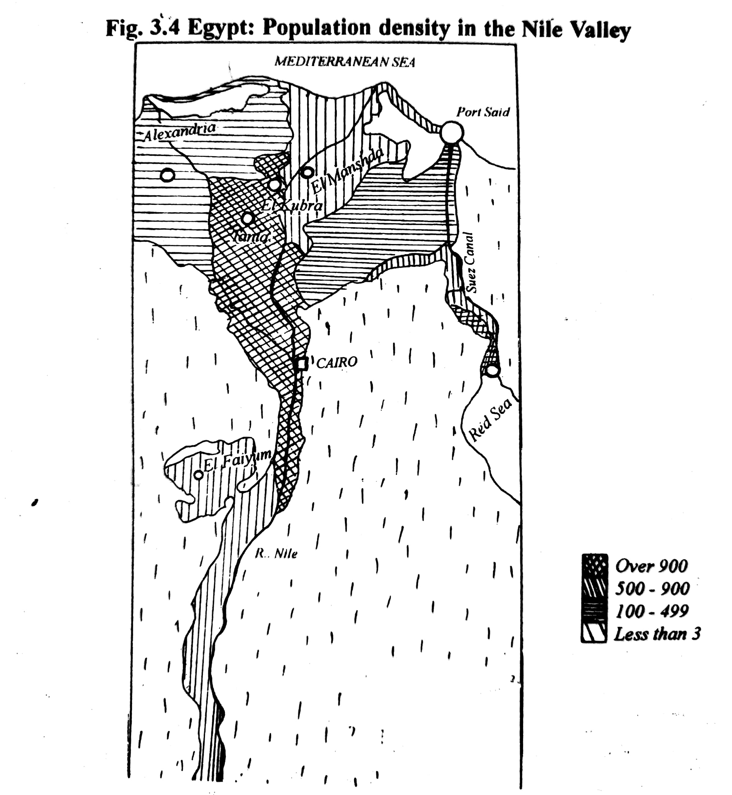

**Activity; understanding the causes of a high population density in the Nile valley and delta areas.**

**Task**

**In groups using knowledge from previous lessons, discuss the causes of a high population density in the Nile valley and delta areas.**

**Learners’ responses**

1. Fertile alluvial soils of the Nile valley and delta which promote crop farming such as cotton and rice growing, hence attracting settlement.
2. Abundant/ Reliable water supply from the Nile River for irrigation, domestic and industrial use.
3. Gently sloping landscape which encourages construction of facilities / mechanization, hence attracting dense settlement.
4. Efficient / developed transport by road and railway which increases accessibility.
5. Presence of many economic activities such as industry which provide employment to many people.
6. Favorable government policy of building of industries and power stations in the area , hence attracting many people to provide labour.
7. Long duration of settlement and historical development in the regions such as early civilizations in Alexandria and Cairo.
8. etc

**Activity; Brainstorming the causes of low population density in other parts of Egypt.**

**TASK**

**In pairs, brainstorm the causes of low population density in other parts of Egypt. Share your work with the rest of the class.**

**Learners’ responses**

1. Little and unreliable rainfall of less than 250mm per annum discouraging crop farming.
2. Limited/ no water supply since it is only limited to the desert oases, hence limiting economic activities and discouraging settlement.
3. Presence of infertile soils which are sandy and rocky limiting crop farming and thus discouraging settlement.
4. Remoteness / underdeveloped transport routes which limit accessibility and thus discourage settlement.
5. Limited economic activities such as industry and thus limited job opportunities.
6. Absence or limited mineral resources hence limited job opportunities leading to sparse population settlement.
7. Etc